**Cup Action!**

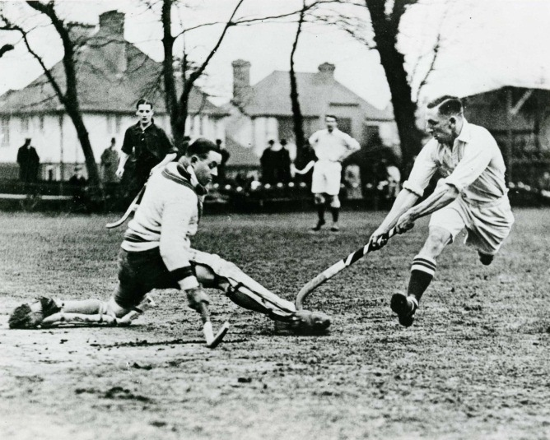

**Sunday 17th Feb**

**England Hockey Over 50s Cup**

**(Round 4 - last 16)**

**Timperley HC Vs Formby HC**

**1.15 pm Start**